Chapter 6 Earth Reinforcement (Figs)
2020.8.25修正
Figure list
Fig.6.1 Geotechnical categories for ground improvement (JGS, 2009)
Fig.6.2 Earth reinforcement vs. soil improvement (JGS, 2009)
Fig.6.3 Tri-axial tests result (Schiosser & Long, 1972)
Fig.6.4 Pseudo cohesion & enhanced cohesion (Schiosser & Long, 1972)
Fig.6.5 Ziegler (2018)
Fig.6.6 Analogy of reinforced soil fail mechanism (Jones, 1992)
Fig.6.7 Embankment Reinforcement (Ingold, 1982)
Fig.6.8 Reinforced foundations for sub-soil (Fukuda et al, 1989)
Fig.6.9 In-situ Reinforcement – Soil nailing (Schlosser and Juran, 1981)
Fig.6.10 Geotextile
Fig.6.11 Geogrid
Fig.6.12 Geocell and Geomat
Fig.6.13 EPS
Fig.6.14 Tire derived Geo-materials
Fig/6.15 Reinforced soil wall (Japan Association of Terre Armee, 2015)
Fig.6.16 Flow of construction procedures
Fig. 6.17 Soil nailing, Micro-piling and Doweling
Fig. 6.18 Illustration of Anchoring
Fig.6.19 Details of Anchor
Fig.6.20 Procedure of soil nailing
Fig.6.21 Stability analysis by slice method

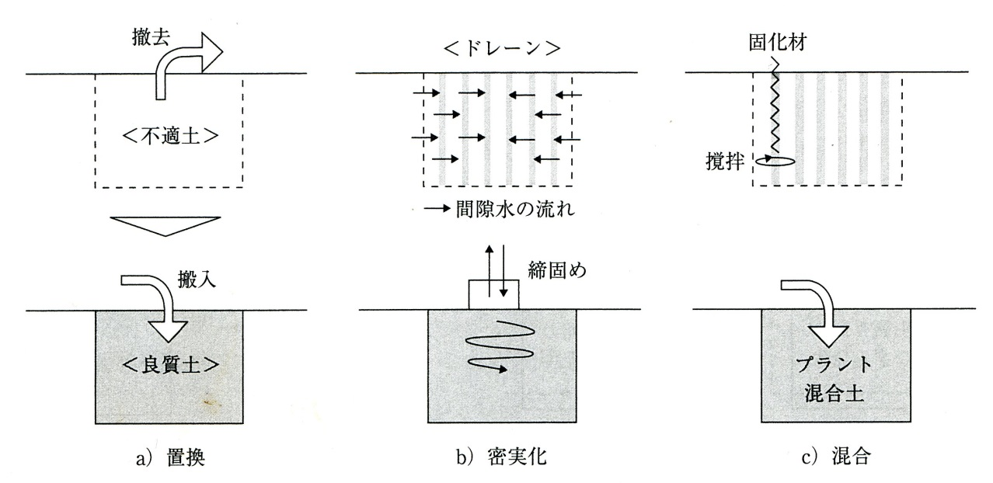
Fig.6.1 Geotechnical categories for ground improvement (JGS, 2009)

撤去：removal ドレイン：drain 固化材：solidifying
不適合土：unsuitable soils 間隙水の流れ：flow of pore water materials
搬入：carrying 締固め：compaction 攪拌：in situ mixing良質土：suitable soils 密実化：densification プラント混合土：
置換：replacement plant mixed soils
混合：mixing

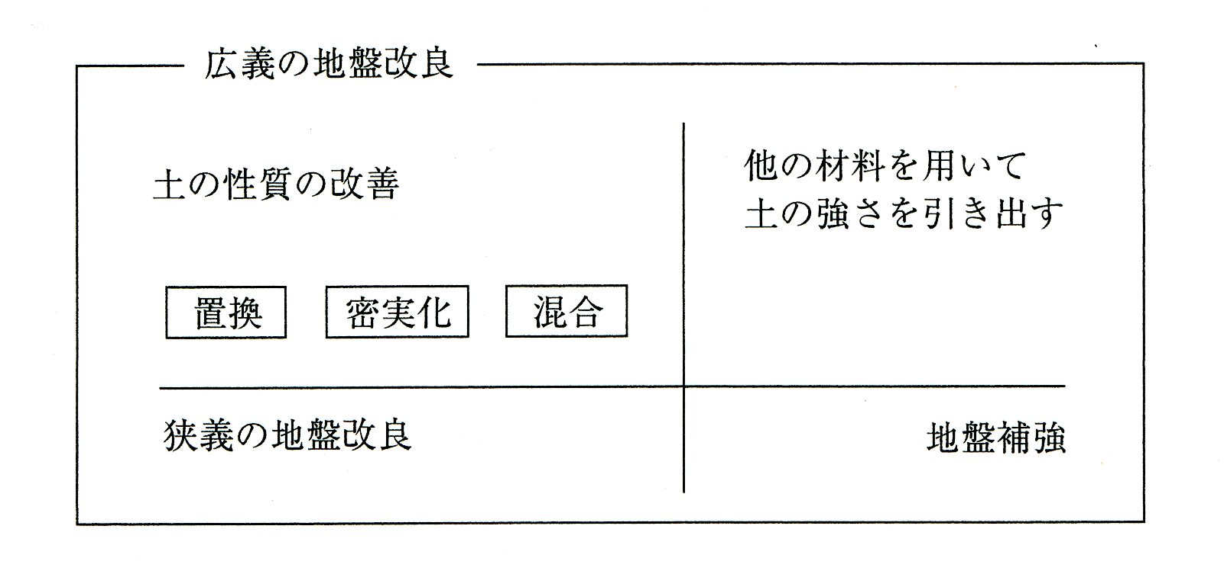
Fig.6.2 Earth reinforcement vs. soil improvement (JGS, 2009)
広義の地盤改良：ground improvement in broad sense
土の性質の改善：modification for soil properties
置換：replacement
密実化：densification
混合：mixing
狭義の地盤改良：ground improvement in narrow sense
他の材料を用いて土の強さを引き出す：mobilizing of soil strength with other
materials
地盤補強：reinforcement soils
ハザリカが新たに作成する。Chapter 1の7つのものを入れる

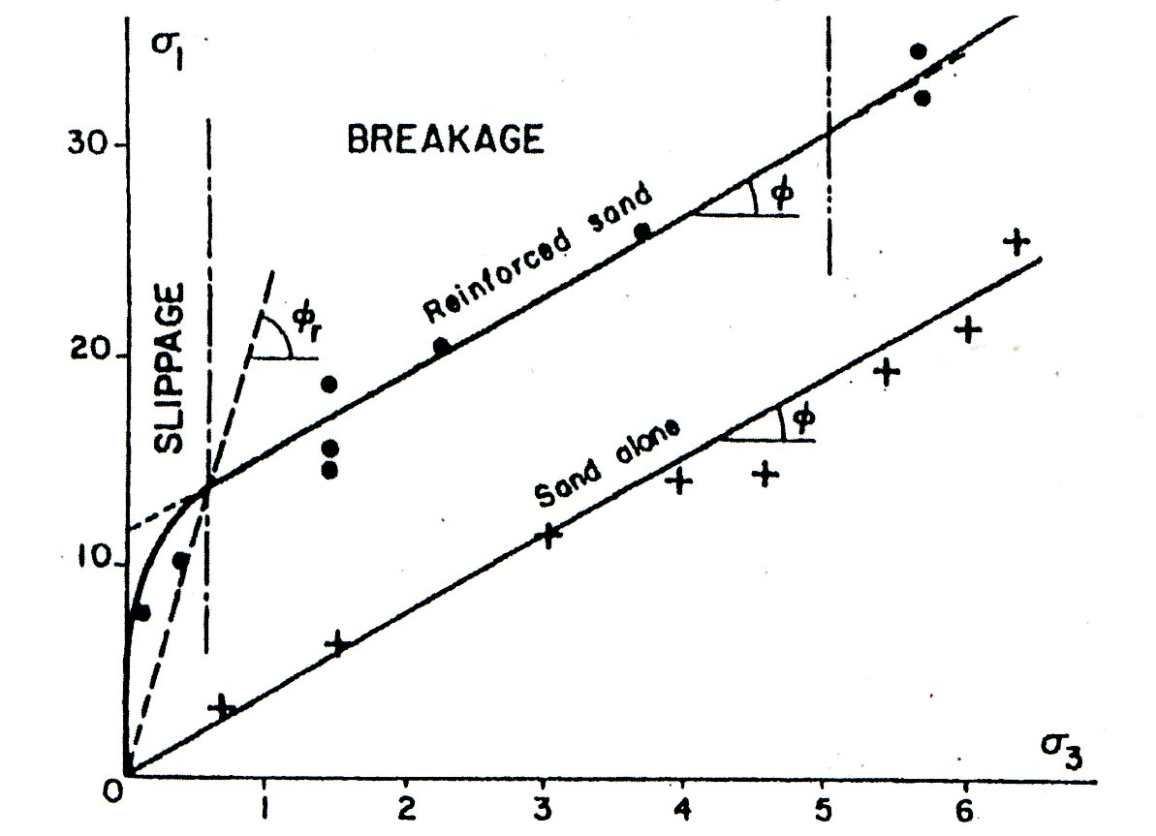
Fig.6.3 Tri-axial tests result (Schiosser & Long, 1972)
概念図として作り直す

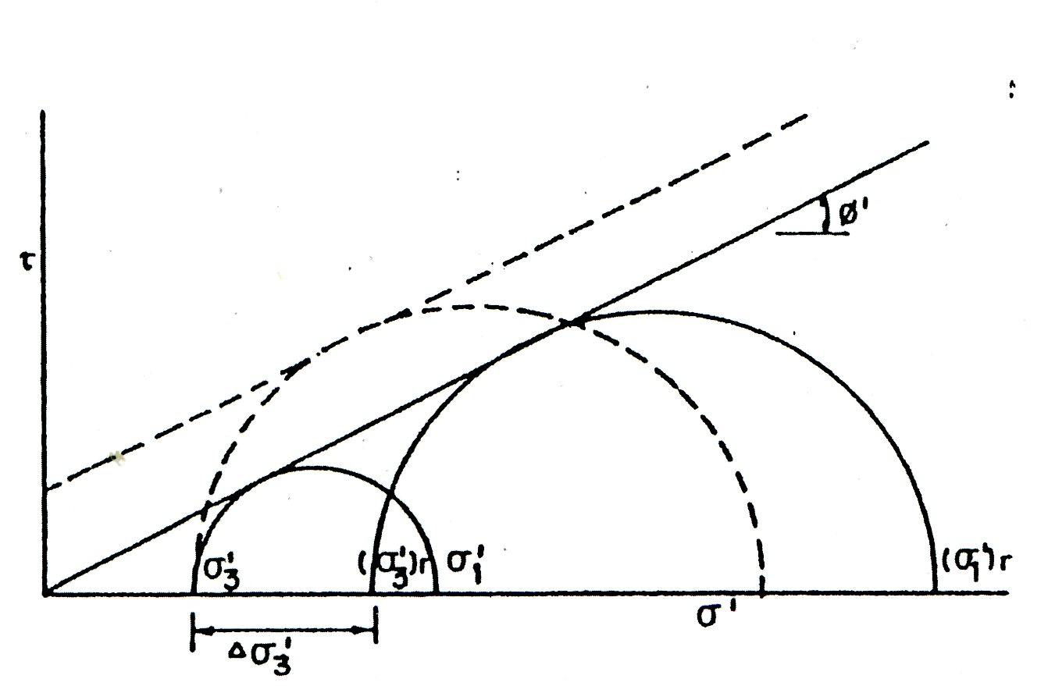
Fig.6.4 Pseudo cohesion & enhanced cohesion (Schiosser & Long, 1972)
概念図として作り直す

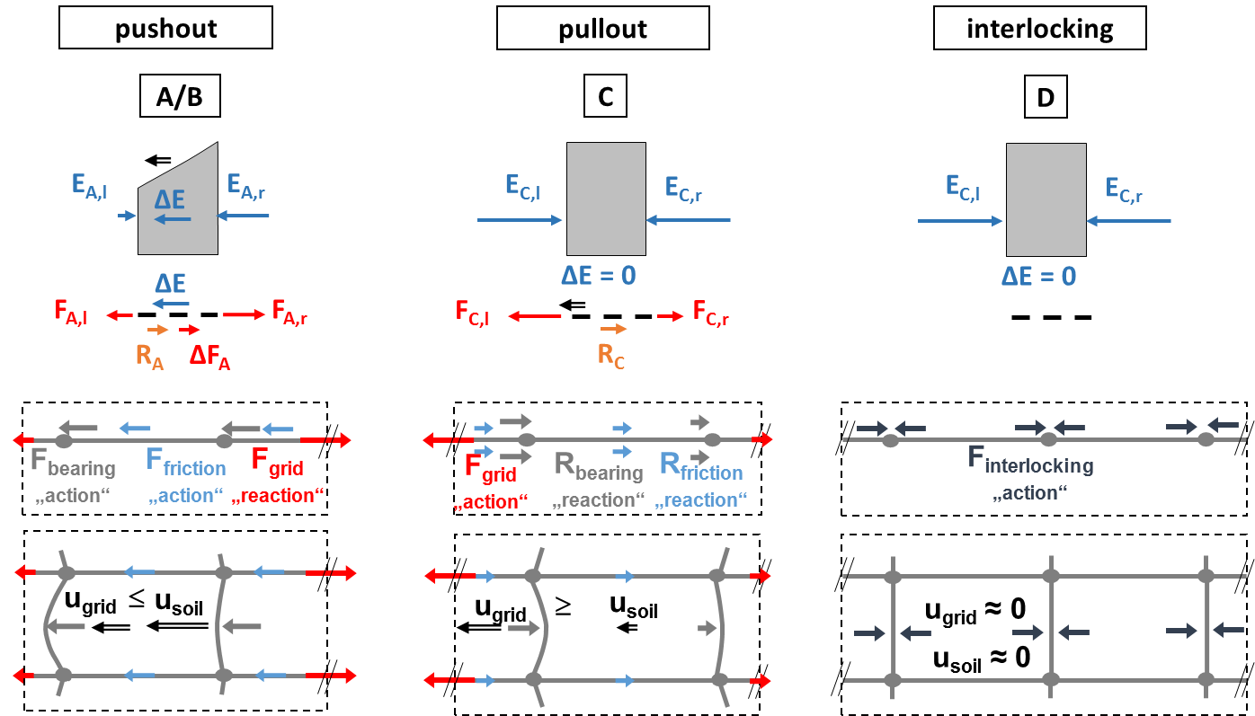
文中に追加説明が必要（論文を引用）
Fig.6.5 Ziegler (2018)
‘20.8.24処理済
タイトルをつける

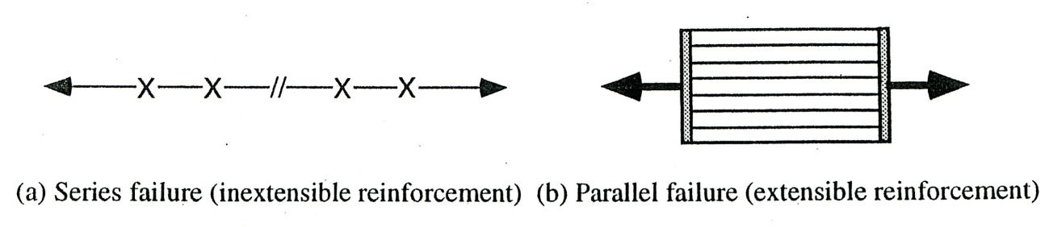
Fig.6.6 Analogy of reinforced soil fail mechanism (Jones, 1992)

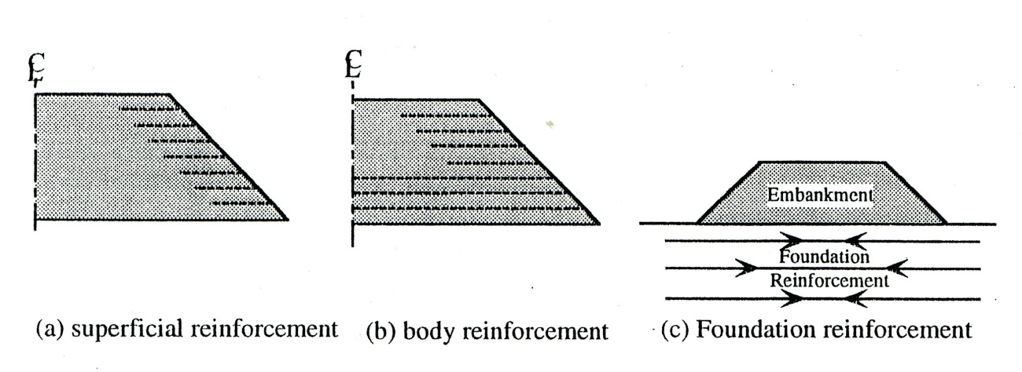
Fig.6.7 Embankment Reinforcement (Ingold, 1982)
ハザリカが書き直す

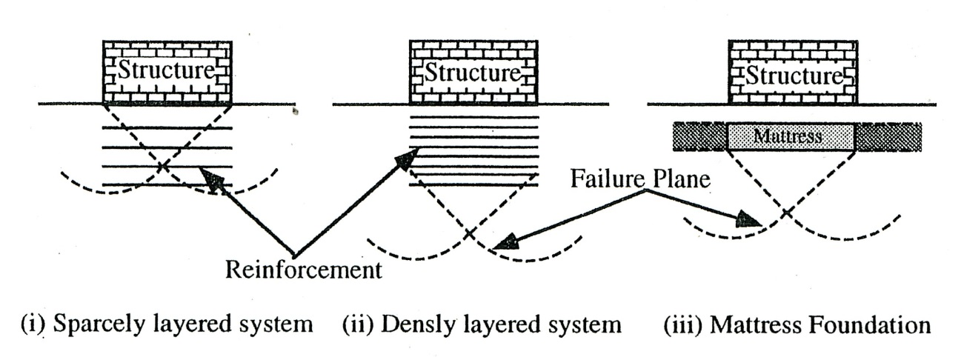
Fig.6.8 Reinforced foundations for sub-soil (Fukuda et al, 1987)

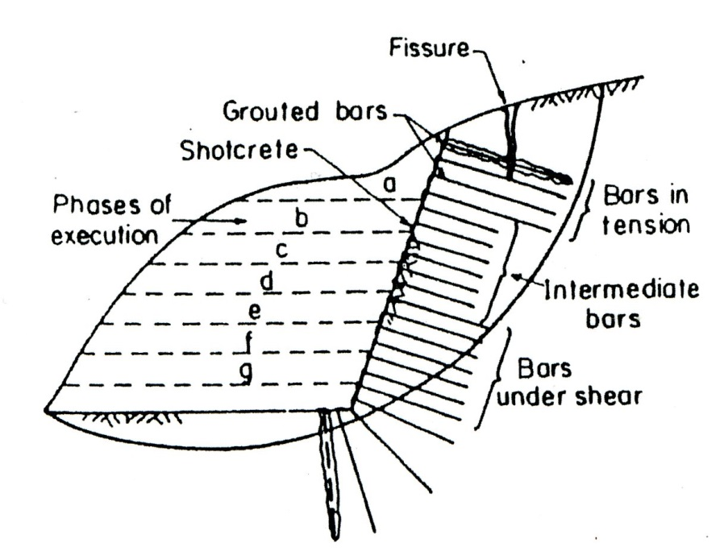
Fig.6.9 In-situ Reinforcement – Soil nailing (Schlosser and Juran, 1980)
できれば置き換える（ハザリカ講義ノート）

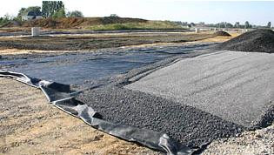
Fig.6.10 Geotextile (Wikipedia, 2020.8.24)

IGSのものをスキャンし、引用する
Wrekin Wrekin Fastrack Woven Geotextile Fabricpavingplace.co.uk
https://www.pavingplace.co.uk/wrekin-fastrack-woven-geotextile-fabric.html
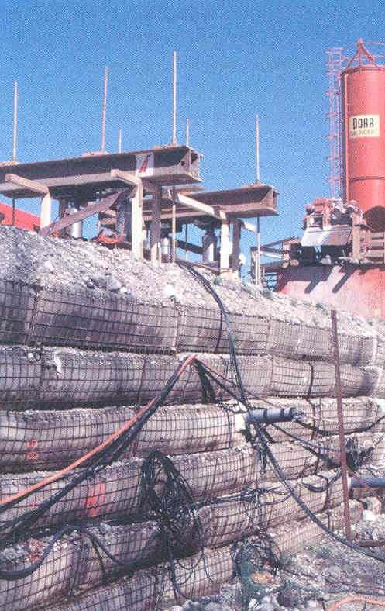

Fig.6.11 Geogrid (Hazarika PP)
ハザリカ講義ノート

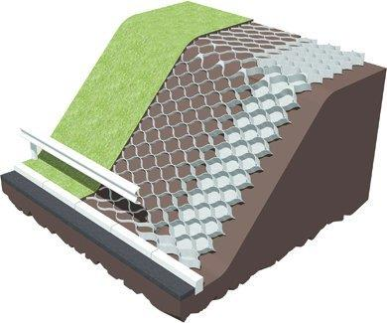
Geomat
Geocell

Fig.6.12 Geocell and Geomat
引用文献を探して、記述する

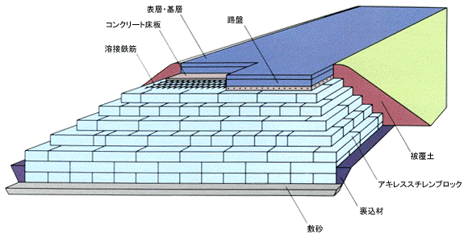

Fig.6.13 EPS
EPS工法の本から引用し、置き換える
敷き砂：sand mat
裏込め材：backfill materials
被覆土：covered soils
路盤：subbase course
表層・基層：surface course and base layer
コンクリート床版：concrete slab
溶接鉄筋：welded rebar
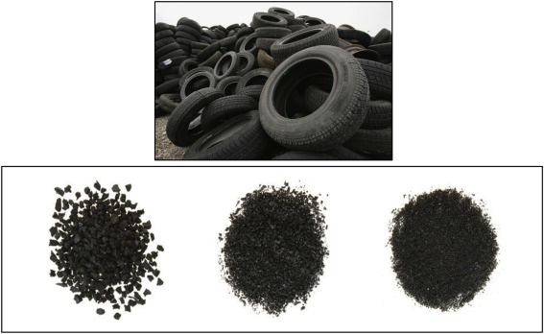
567x348Recycling waste rubber tyres in construction materials and ...sciencedirect.com
Fig.6.14 Tire derived Geo-materials (Wikipedia, 2020.8.24)
ハザリカの論文から引用し、置き換える

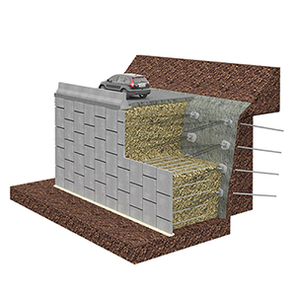
図の変更（ハザリカ）2020.8.9打ち合わせ
処理済、‘20.8.24
 | Function | Materials
Component | Reinforcement | Strip (Steel band, Ribbed steel band), Geogrid
Component | Facing wall | Skin (Concrete skin, Metal skin)
Component | Connection | Bolt, Nut,
Component | Embankment | Sandy soil etc.
Fig.6.15 Reinforced soil wall (Japan Association of Terre Armee, 2015)
コンクリートスキン：concrete skin
コネクティブ：connectible parts
ボルトナット：bolt and nut
ストリップ：strip
基礎工：foundation

追加の説明が必要（中澤先生が作成する）

Site preparation

Foundation work
Assembling of concrete skins

Repeating work
to design height
Installing of strips

Spreading of banking soils
Compacting of soils

Incidental work

End

Fig.6.16 Flow of construction procedures (Japan Association of Terre Armee, 2015)

 | Soil nailing | Micro-piling | Doweling  Shotcrete
Illustration | 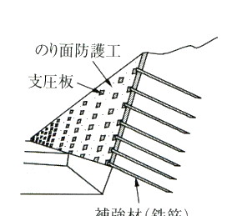  Slope face protection  Bearing plate  Reinforcement (Rebar) | 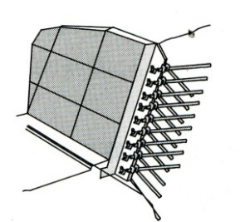 | 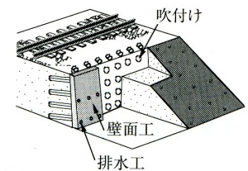  Drainage  Wall face
Note | Rebars, which have large slenderness ratios and small bending stiffness, are applied. Ground is reinforced by tension of rebars. | Rebars, which have intermediate values between  soil nailing and doweling, are applied.. | Rebars, which have small slenderness and large bending stiffness, are applied. Ground is reinforced by tension, bending and compressing resistance of rebars.
Fig.6.17 Soil nailing, Micro-piling and Doweling
引用文献を入れる（地盤工学会？？）

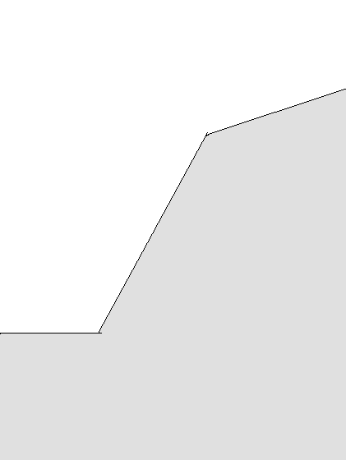
Anchor rod
Grouting mass
Fig.6.18 Illustration of Anchoring

Anchor frame
Anchor head
Anchor rod
Grouting mass

注：原図と照合すること

Fig.6.19 Details of Anchor ( )

Installation of reinforcement (step 1)
Slope protection (step 1)
Backhoe
Spraying
Drilling machine
Excavation (step 2)
Excavation (step 1)

Fig.6.20 Procedure of soil nailing ( )

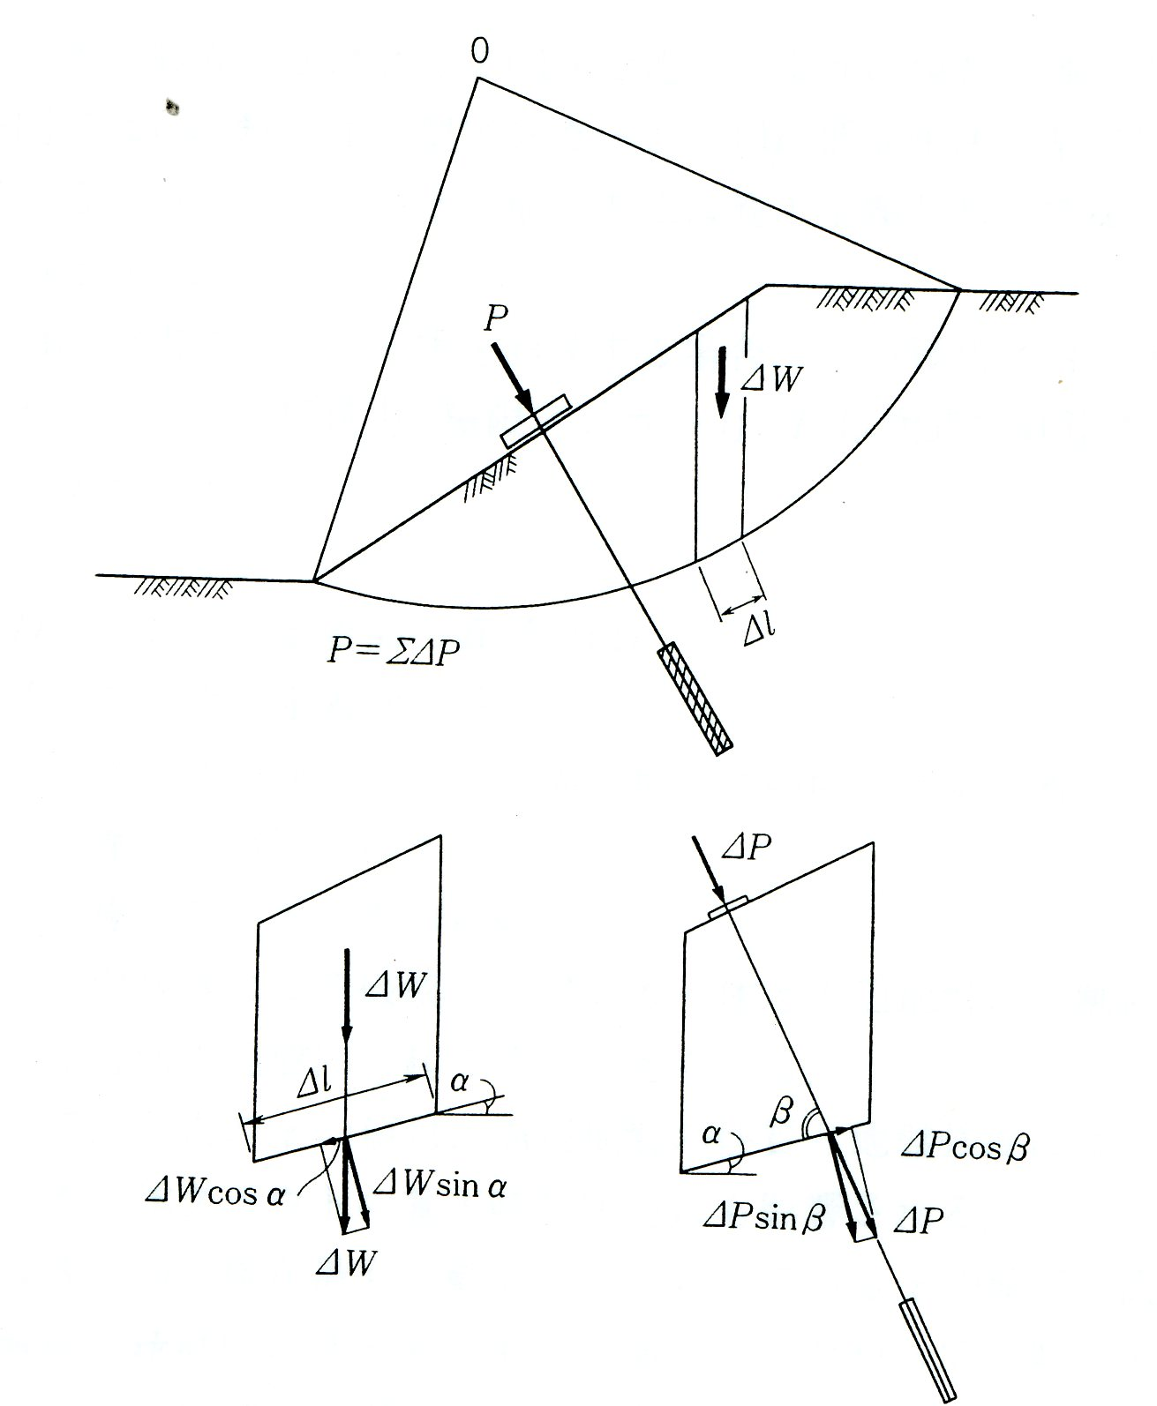
Fig.6.21 Stability analysis by slice method （Yonekura at el. 1998）

